A+ Computer Science WATER HAZZARDS

Lab Goal: This lab was designed to teach you more about using method calls to solve problems. You must get comfortable with single Jeroo methods being called multiple times in solving problems that involve the same actions being repeated. This lab requires precision in making sure your Jeroo accomplishes his assigned job. You must also calculate out how many flowers are needed to complete the job.
Lab Description: Create a single method that allows your Jeroo to protect the other Jeroos by enclosing a single waterhole with a wall of flowers as a signal of the dangerous areas of the island.

Starting Screen:
Files Needed ::
water.jsc
water.jev

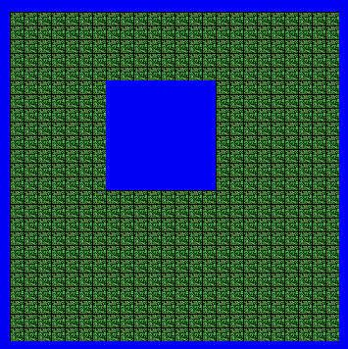

algorithm help

Preconditions –
- How many Flowers to start

Postcondition –
- Water Hole / Lake protected by flowers
- Jeroo stops when finished

Ending Screen:
